# Experiment 1.2

**Student Name: Suvigya Yadav UID:21BCS9206**

**Branch: BE-CSE Section/Group: CC-646-B**

**Date of Performance:23-01-2024 Subject Code: 21CSP-378**

**Subject Name: Cloud Computing & Semester: 6 Distributed Systems**

# Aim:

To install a C compiler within the virtual machine established using VirtualBox and run basic programs.

# Objective:

To run a basic C program in the virtual machine through terminal in the VirtualBox on a Windows 10 operating system.

# Steps to Install:

Step 1: Open the terminal in the virtual machine and run SUDO APT UPDATE to update all the local package.

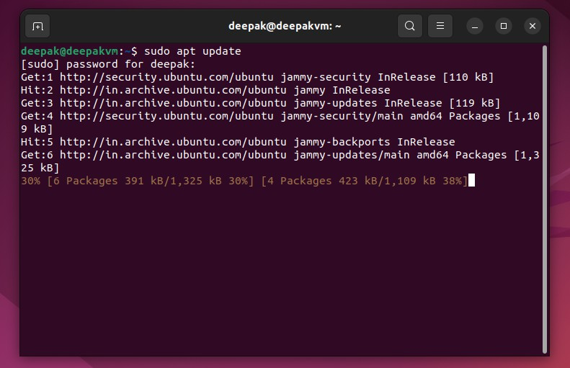

Step 2: Once completed clear the screen and install gcc complier through the command “sudo apt install build-essential” or “sudo apt install gcc”.

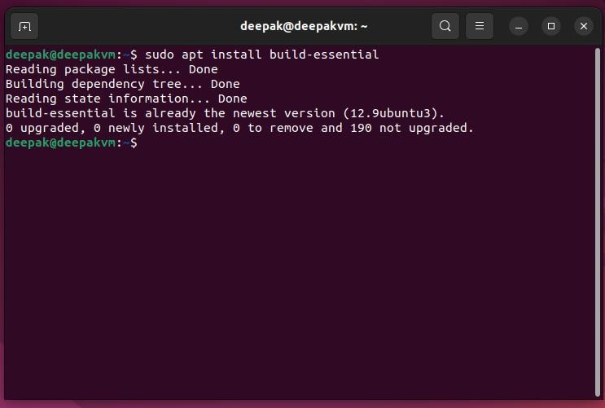

Step 3: Once installed check the version of the gcc and g++ compilers .

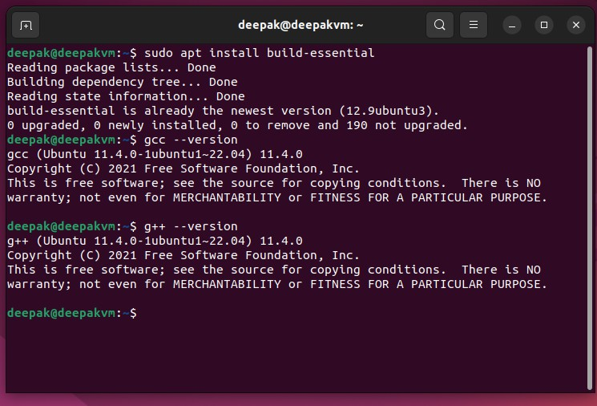

Step 4: Now go to directory and make a new file ‘touch first.c’

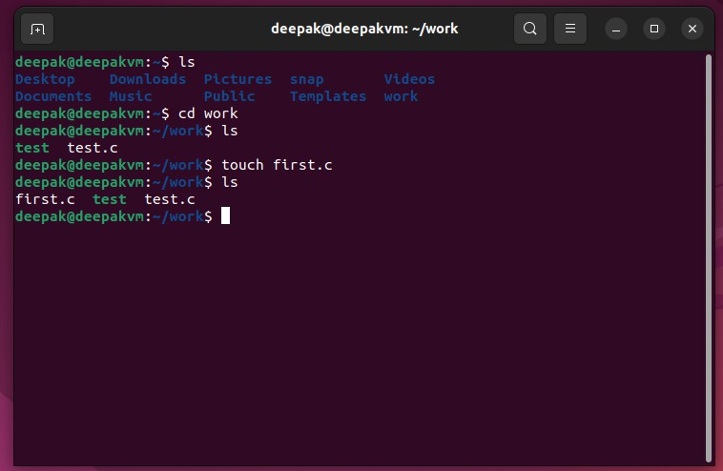

Step 5: Once file is created , edit it by the “gedit filename.c” command.

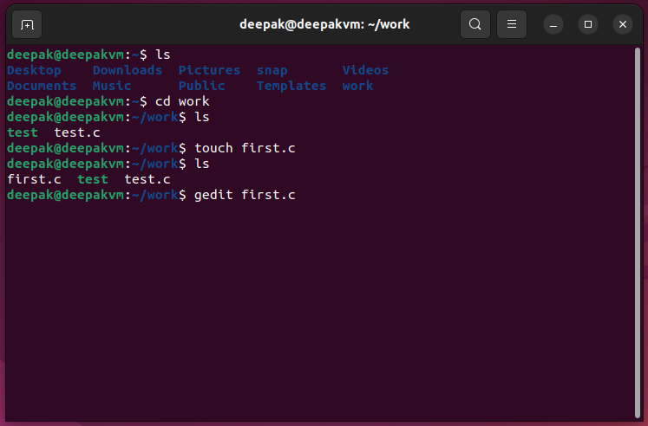

Step 6: After that text editor will pop up , write the code , save it and close it.

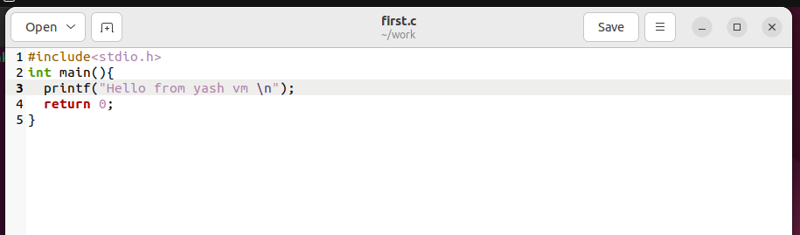

Step 7: Now compile the code by the “gcc filename.c” command and run the executable file by “./a.out ” command

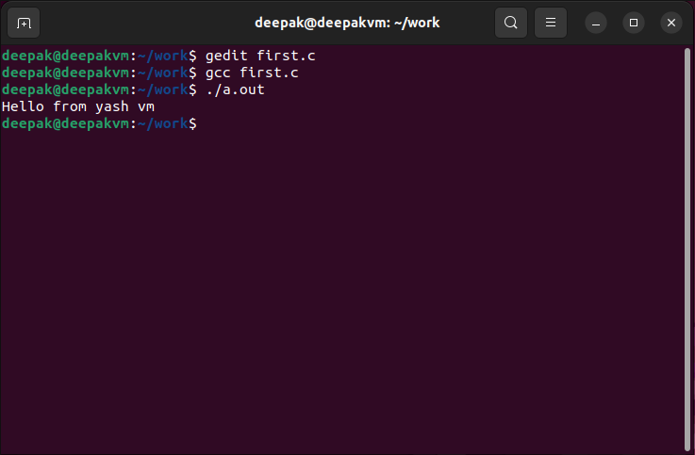

# Learning Outcome:

* Learn how to update packages.
* Understand how to install C compiler.
* Understand how to create file, compile and run the executable file.
* Learned how to run any c program on the Linux terminal through various commands.